**The Sentiment Effect**

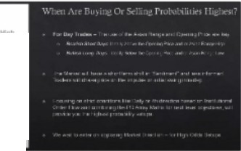

!Ti_

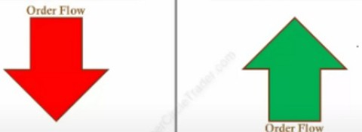

**Smart Money Sells Bullish Sentiment**

**Asian Range High Asian Range High**

**Asian Range Low**

**Asian Range Low**

**Smart Money Buys**

**Beartsh Sentiment**

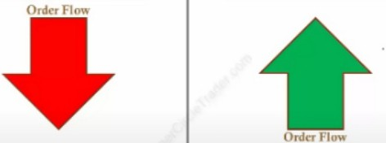

**Street Money Buys 8ulllsh Sentiment**

**Asian RanRe HIRh Asian Range High**

**Asian Range Low**

**Asian Range Low**

**Street Money Sells**

**Beartsh Sentiment**

Known as the judas swing

Smart money sells above the asian range high on bearish days

Opening price is either O GMT early if its been in consolidation, so when the range from O GMT hasnt produced much of a range to the upside and downside you can still occur that price opening as well. But in this teaching we'll primarily focus on the MNO

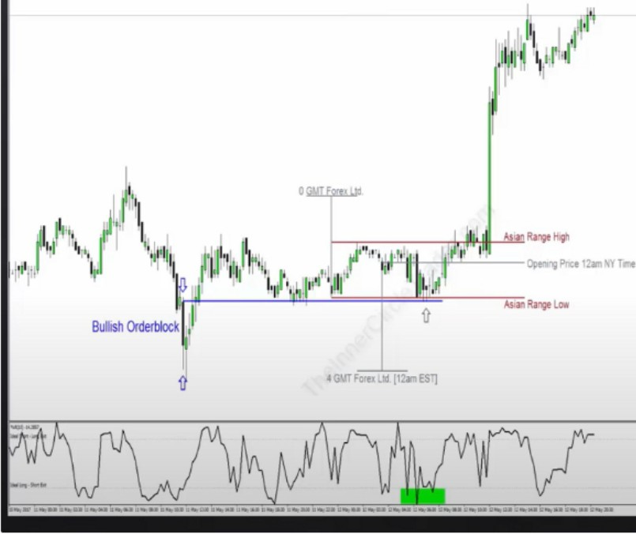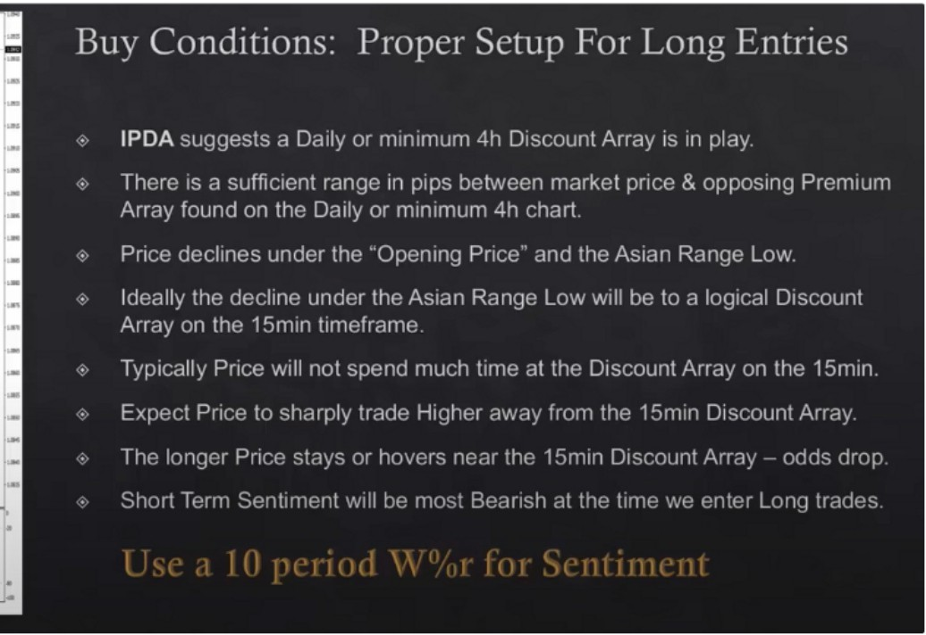

Price has recently respected or traded into a daily or 4h PD array and its showing willingness to support price, we had a reaction of some sort. If we see that and institutional orderflow is bullish then we have very high odd for buy daytrades

is there enough off of a range to profit if you want to be a buyer, 50-60 pips ideally

We want to see immediate response from the 15m discount array, the banks wont keep price at a discount very long if its going to be good

Important: Short term sentiment will be bearish at the time we enter long trades, think opposite of the mass. I need to practice this

For sentiment purposes, use a 10 period W¾r on the 15m timeframe

We dont look at the overbought or oversold, we look at price primarily and if we get a sentiment confluence like we see in the example below then this means were probably going to be on the right side of the market

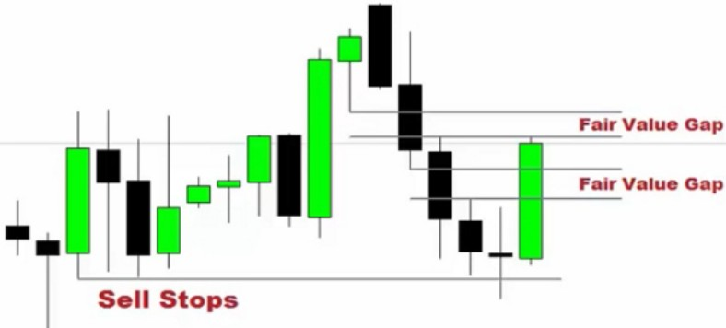

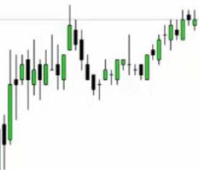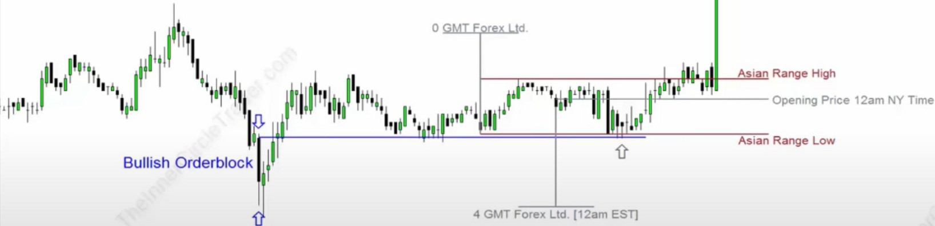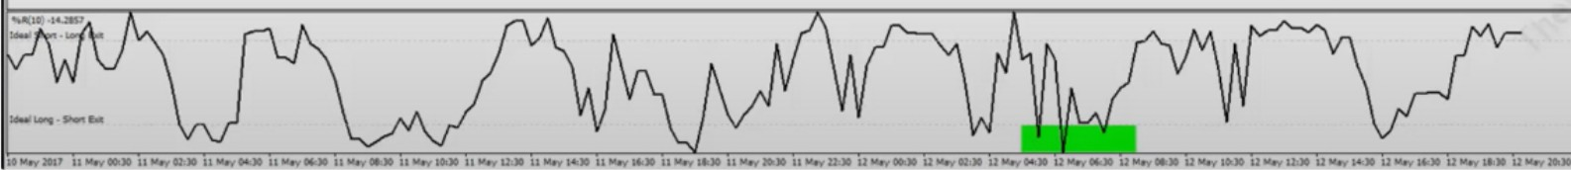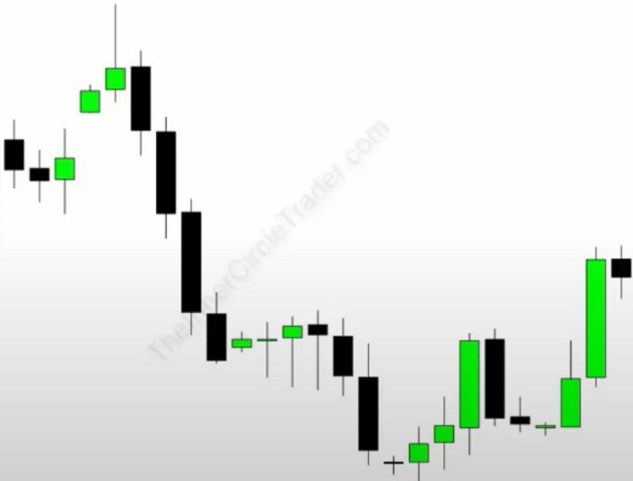

So we had a draw on a discount array and then move to premium array

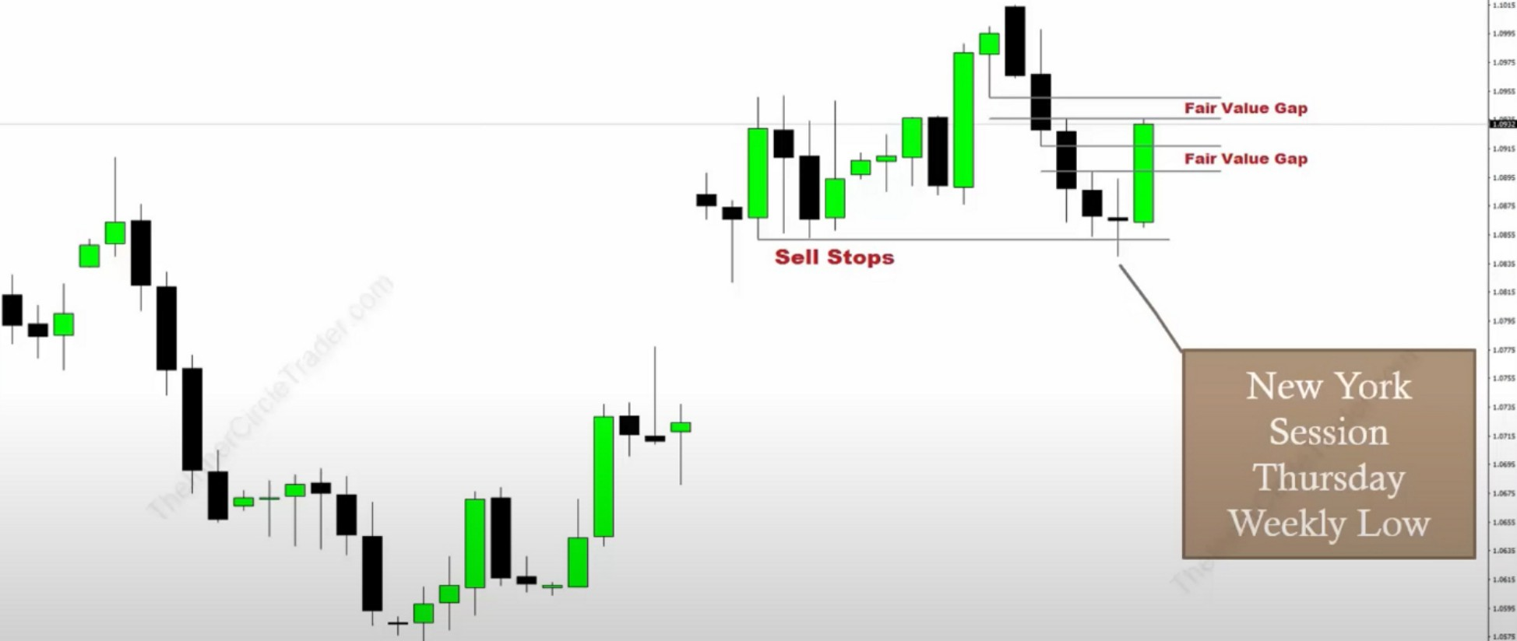

They hit the intraday stops on new york open 830 but they did it before the news numbers released and thats not good and theyre probably pricing in the low of the week, and that happened here

Sell conditions: proper setup for short entries

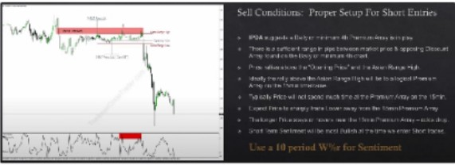

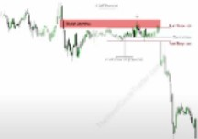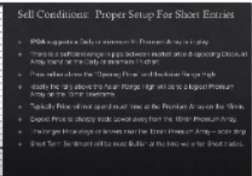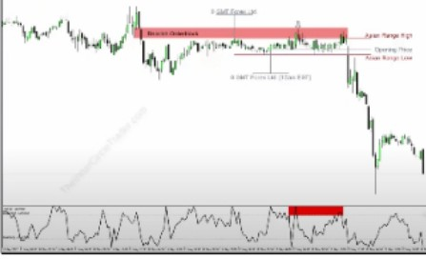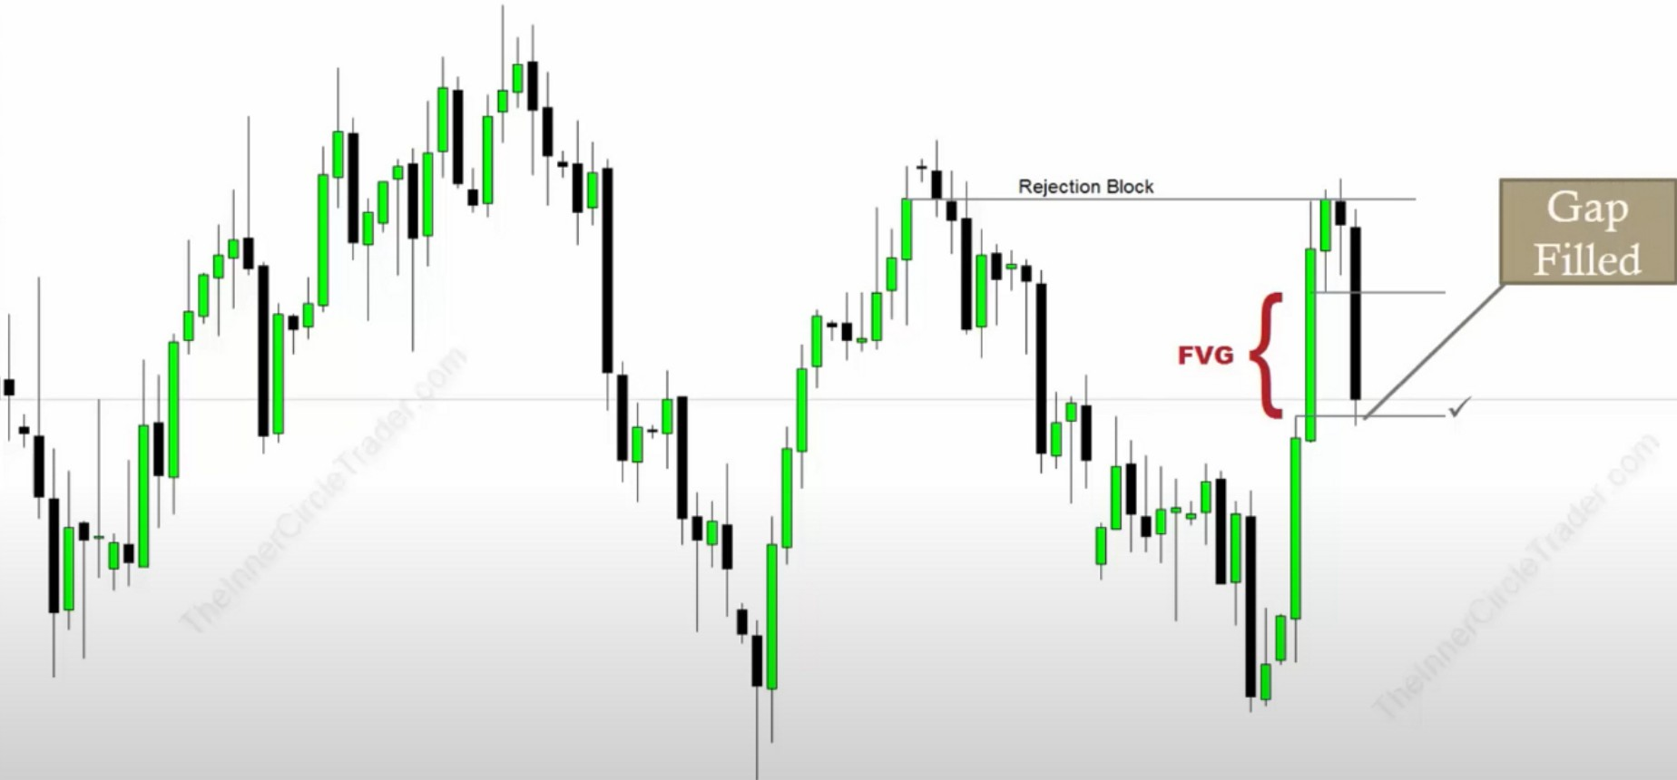

From premium array to a discount array

Notice how the criteria here dont give you a setup every day

It wont give you an opportunity every day, day trading does not mean trading every single day. Its not healthy either, not good for long term success. The more you trade the more risk and the faster that next loss is going to come

Using sentiment and a rule based idea around the asian range, this helps us fare out the better trades, we wont get this condition every single trading day, but the days that we do those are the highest probability for daytrading

Arjo I Twitter, lnstagram I Linktree

Linktree. Make your link do more.

, https://t.co/HhmmTN1fUI

JavaScript is not available.

'I# https://twitter.com/arjoio